

KENDRIYA VIDYALAYA NO.2 ITANAGAR

SESSION:- 2022-2023

TOPIC: HOSPITAL MANAGEMENT SYSTEM

SUBMITTED BY: SUBMITTED TO:

-JATIN KUMAR -SAROJ K. MISRA SIR PGT (CS)

CLASS:- ‘XII’ ‘A’ ROLL NO.:- 24 CBSE ROLL NO.:-

CERTIFICATE

This is to certify that **JATIN KUMAR** of class: **XII A** of **KENDRIYA VIDYALAYA NO.2**

has done his project on **HOSPITAL MANAGEMENT SYSTEM** under my supervision. He has taken interest and has shown at most sincerity in completion of this project.

I certify this project up to my expectation & as per guidelines issued by **CBSE, NEW DELHI.**

*Internal Examiner External Examiner*

*principal*

ACKNOWLEDGMENT

It is with pleasure that I acknowledge my sincere gratitude to our teacher, ***MR. S.K. MISRA*** who taught and undertook the responsibility of teaching the subject computer science. I have been greatly benefited from his classes.

I am especially indebted to our Principal ***MR. K R MEENA*** who has always been a source of encouragement and support and without whose inspiration this project would not have been a successful I would like to place on record heartfelt thanks to him.

Finally, I would like to express my sincere appreciation for all the other students for my batch their friendship & the fine time that we all shared together

# HARDWARE AND SOFTWARE REQUIRED

**HARDWARE**

1. PC
2. MOBILE PHONE

# SOFTWARE

* + PYTHON (latest version)
  + MYSQL
  + PYTHON CONNECTOR

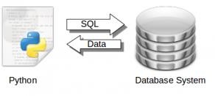

**HOSPITAL**

A hospital is a health care institution providing patient treatment with specialized staff and equipment. Hospital are usually funded by public sector by health organizations (for profit or non-profit), by health insurance companies, or by departments (e.g. , surgery, and urgent care etc).

# HOSPITAL MANAGEMENT SYSTEM

A hospital management system is an information system that manages the aspects of a hospital. This may include the administrative, financial, and medical processing. It is an integrated end-to-end Hospital Management System that provides relevant information across the hospital to support effective decision making for patient care, hospital administration and critical financial accounting, In a seamless flow. This program can look after Inpatients, OPD patients, records, database treatment, status illness, billing etc. it also maintains their hospital info such as ward id, Doctor in charge, Department administering etc.

# NEED OF HMS

1. Minimized documentation and no duplication of records.
2. Reduced paper work.
3. Improved patient care
4. Better Administration Control
5. Faster information flow between various departments
6. Smart Revenue Management
7. Effective billing of various services
8. Exact stock information

# INTRODUCATION

The project Hospital Management System includes registration of patients, storing their details into the system. The software has the facility to give a unique id for every patient and stores the details of every patient and the staff automatically. It includes a search facility to know the current status of each room. User can search availability of a doctor and the details of a patient using the id. The Hospital Management System can be entered using a username and password. It is accessible either by an administrator or receptionist. Only they can add data into the database. The data can be retrieved easily. The interface is very user-friendly. The data are well protected for personal use and makes the data processing very fast.

The purpose of the project entitled as “HOSPITAL

MANAGEMENT SYSTEM” is to computerize the Front Office Management of Hospital to develop software which is user friendly, simple, fast, and cost-effective. It deals with the collection of patient’s information, diagnosis details, etc., and also to manipulate these details meaningfully System input contains patient details, diagnosis details; while system output is to get these details on to the screen.

# EXISTING SYSTEM

* + In today’s world if someone wants to book a Doctor’s Appointment we need to call in clinic or personally go to that place and book the appointment.
  + This consumes precious time of the patient. Also if the doctor cancels his /her schedule, the patient does not come to know about it unless he/she goes to the clinic.

## DISADVANTAGES OF EXISTING SYSTEM

1. Lack of privacy
2. Risk in the management of the data.
3. Less security
4. Less user-friendly
5. Accuracy nor guaranteed
6. Not in reach of distant users.
7. There is no storage and automation if users have some enquiry.

# ADVANTAGES OF HMS

* Less paperwork
* Costs Reduction
* Improves patient’s experience
* Improve data security
* Better collaboration & Communication
* Analytic anytime anywhere

## MODULE LIST

ADMIN

* + ADD PATIENTS
  + ADD STAFF
  + VIEW PATIENTS RECORD
  + VIEW STAFF RECORD
  + CHANGE PASSWORD
  + REMOVE PATIENTS
  + REMOVE STAFF
  + UPDATE PATIENT
  + UPDATE STAFF INFORMATION
  + ADD DOCTOR
  + REMOVE DOCTOR
  + CHECK DOCTOR JOB STATUS PATIENT
  + BOOK APPOINTMENT
  + FIND DOCTOR
  + VIEW DOCTOR PROFILE DOCTER
    - LOGIN
    - APPLY JOB
    - VIEW APPOINTMENT

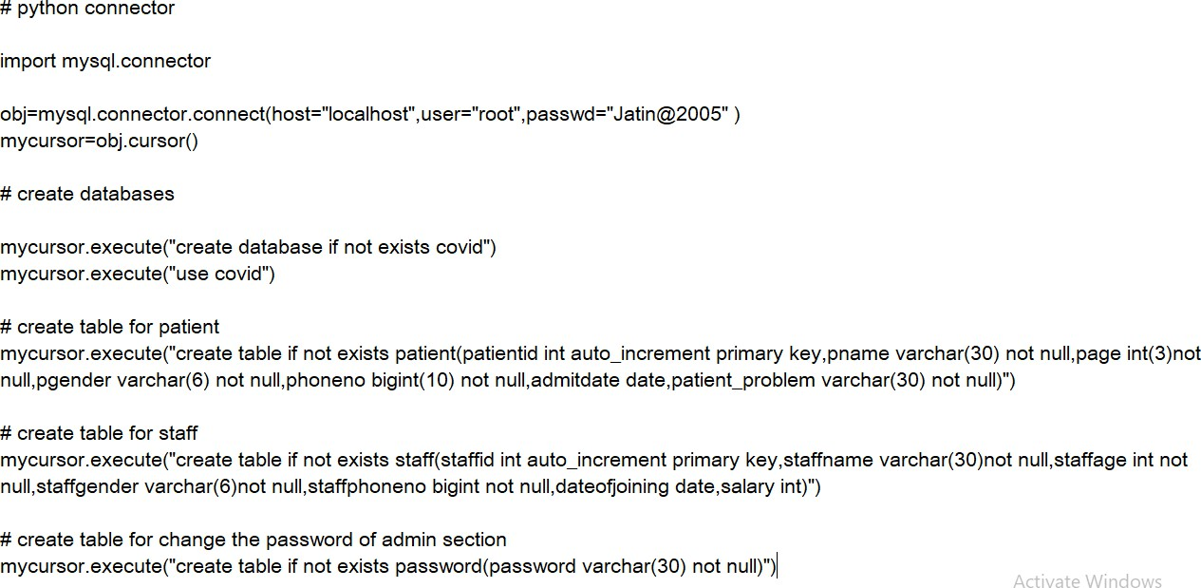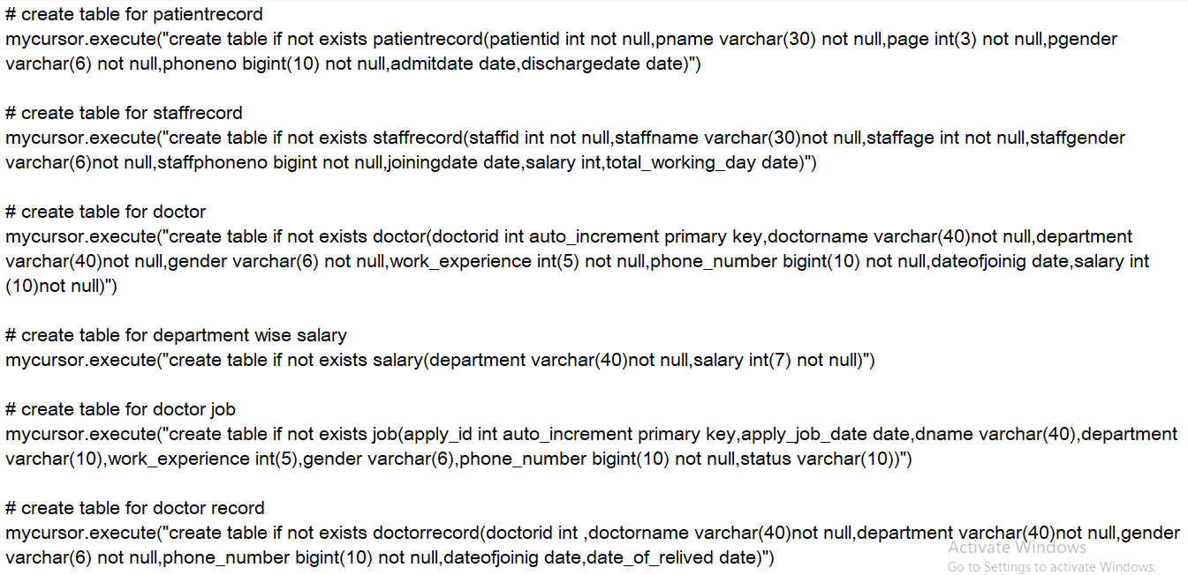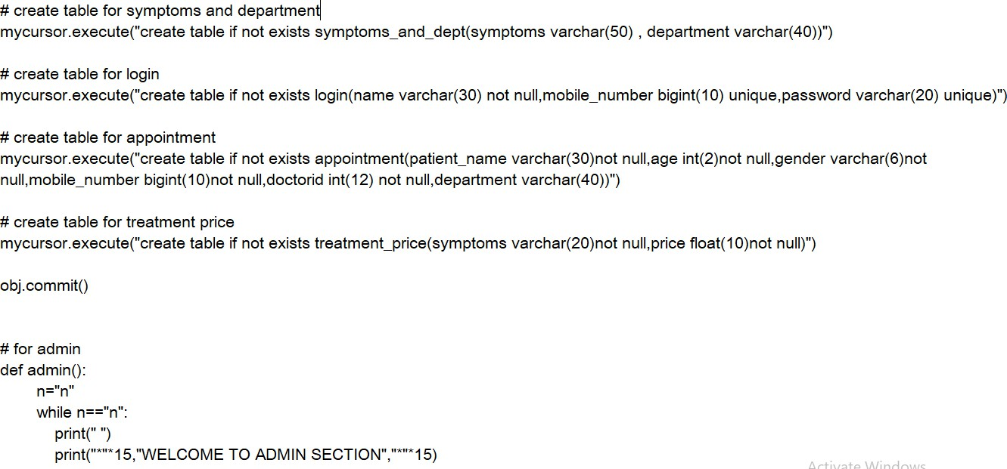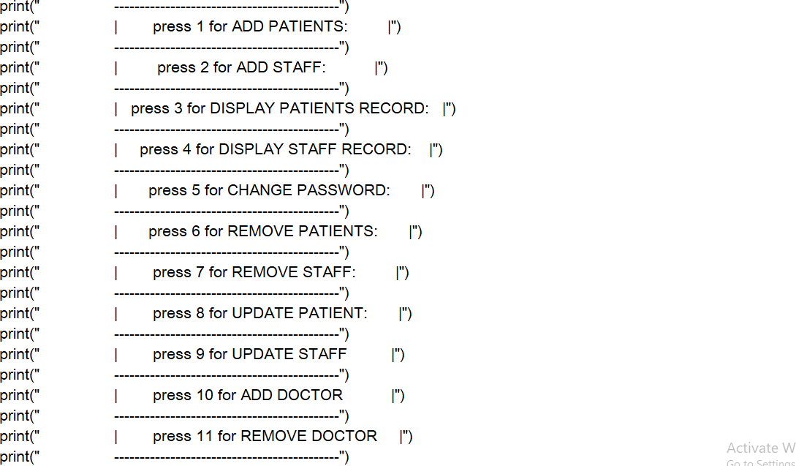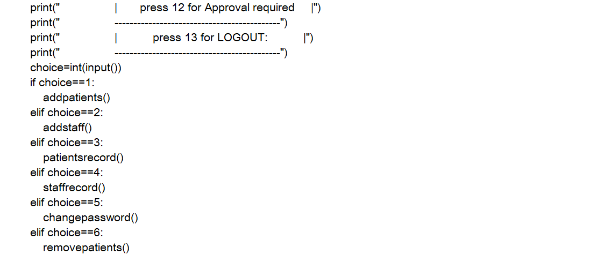

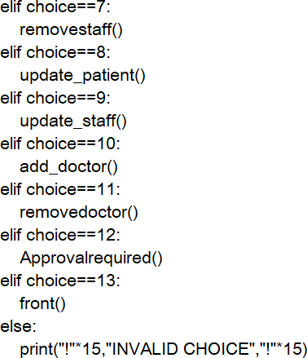

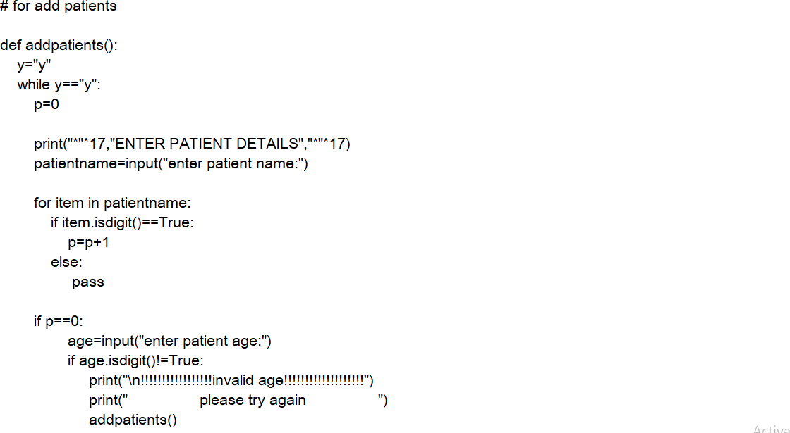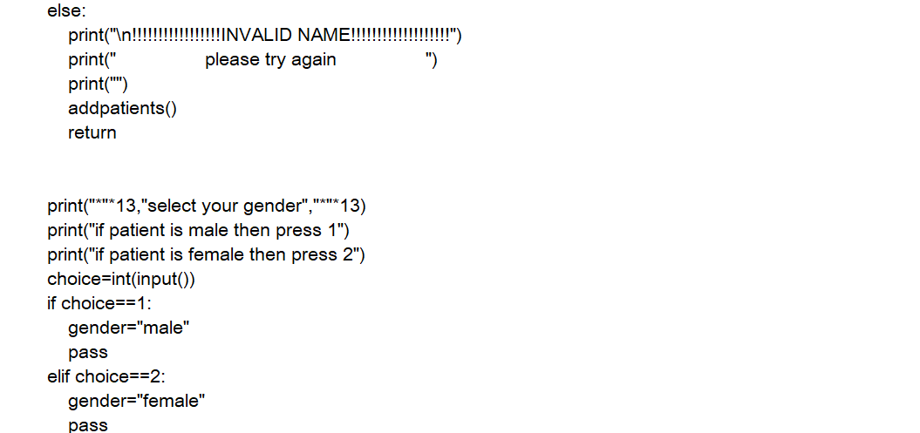

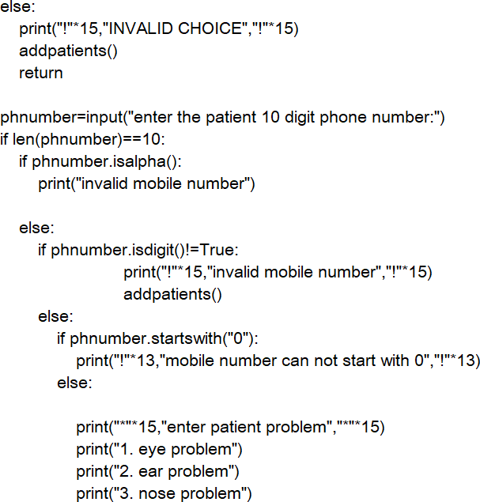

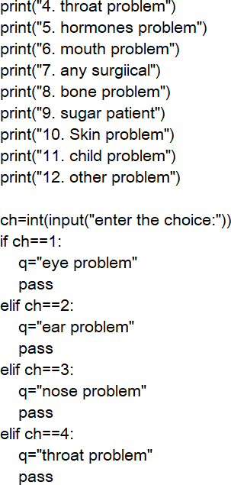

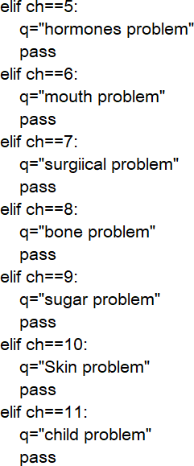

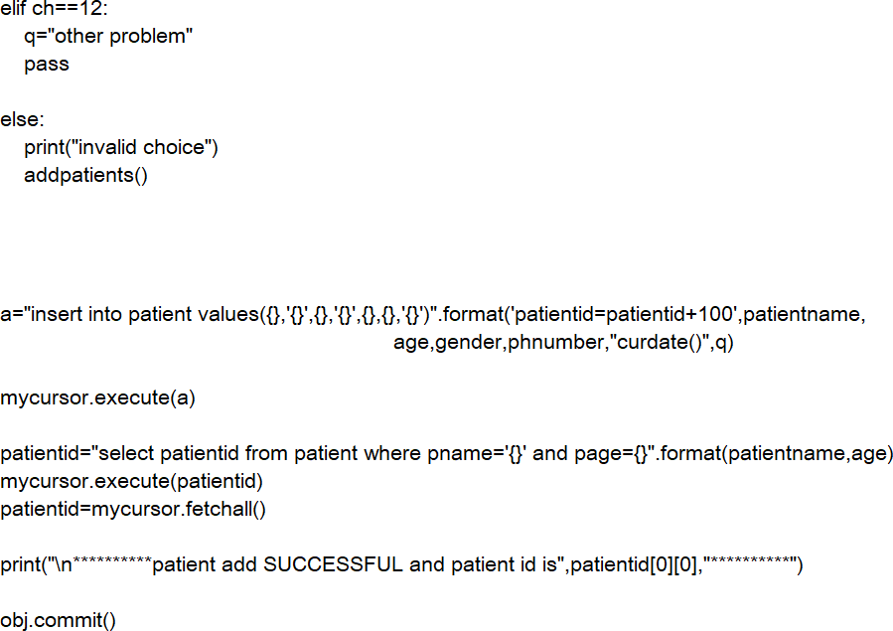

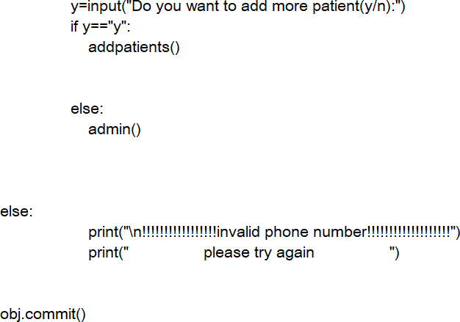

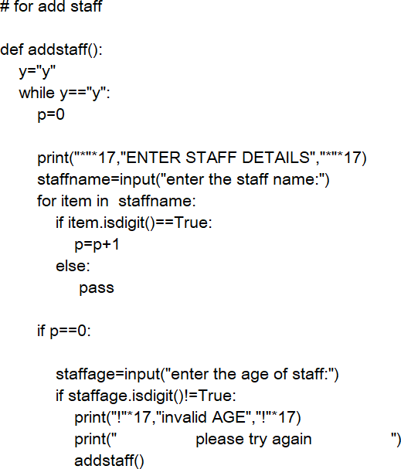

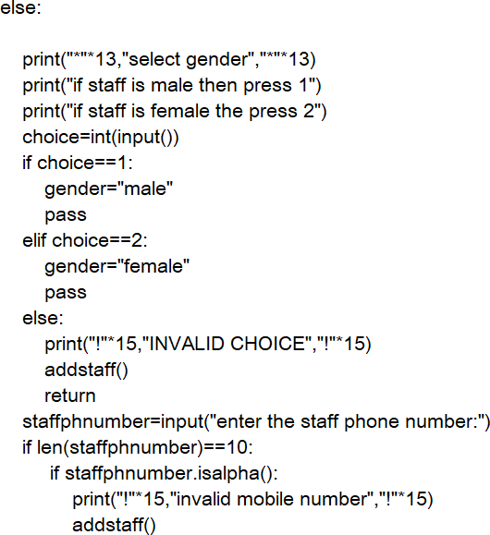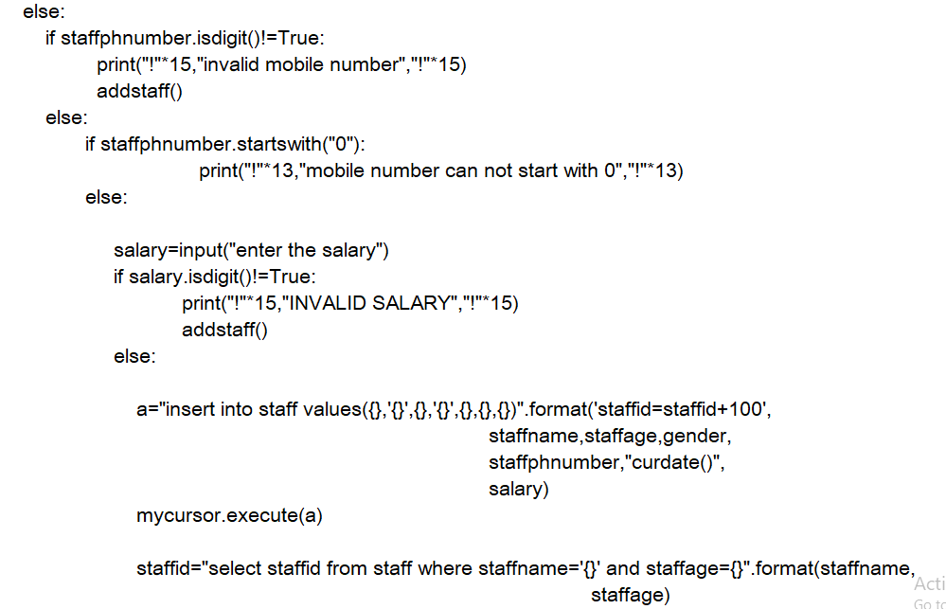

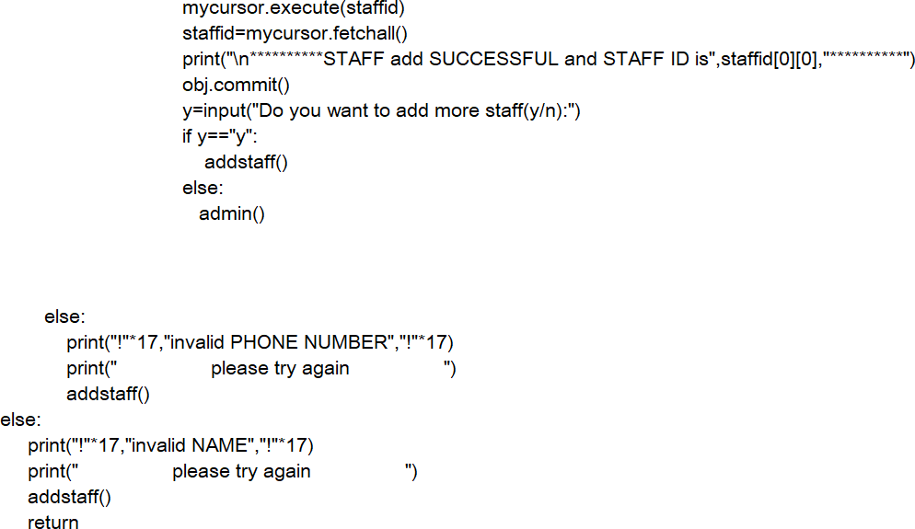

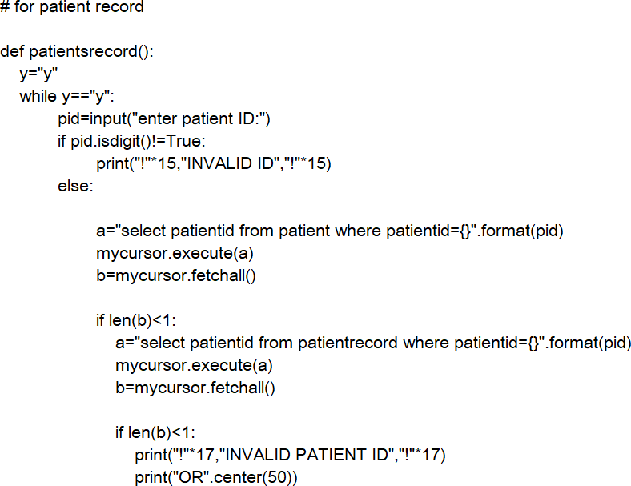

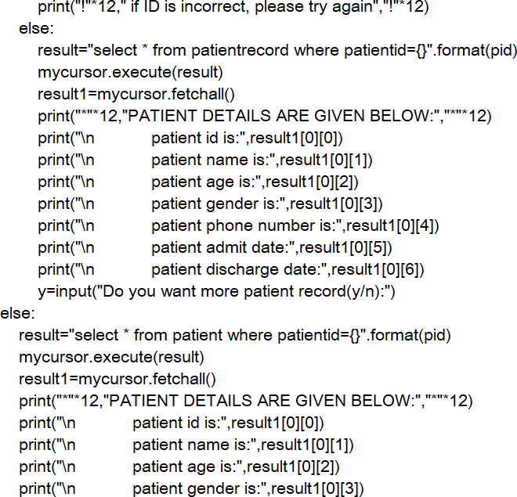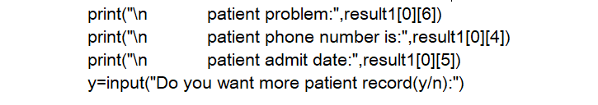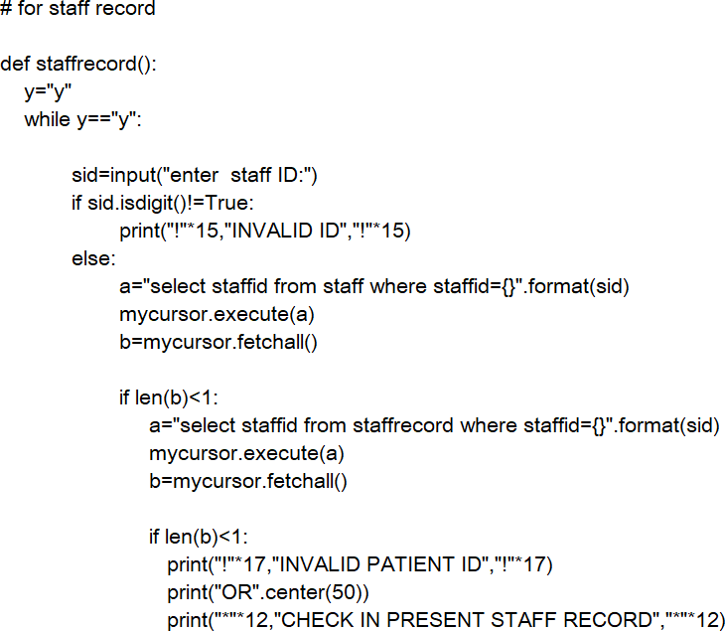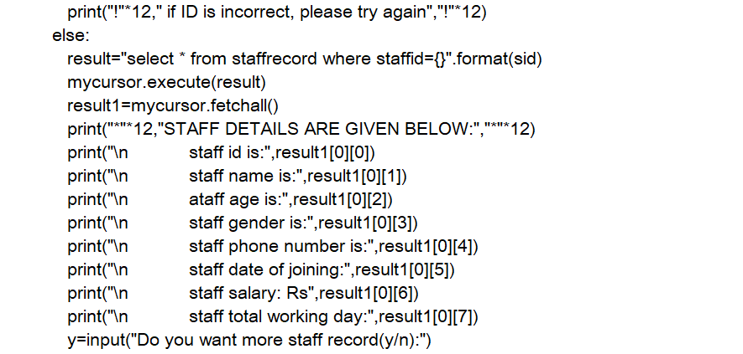

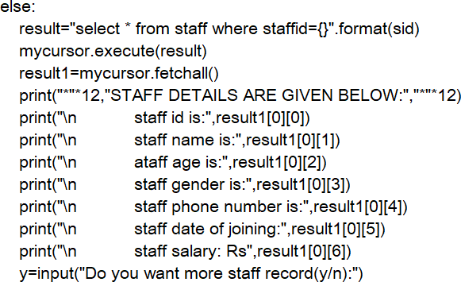

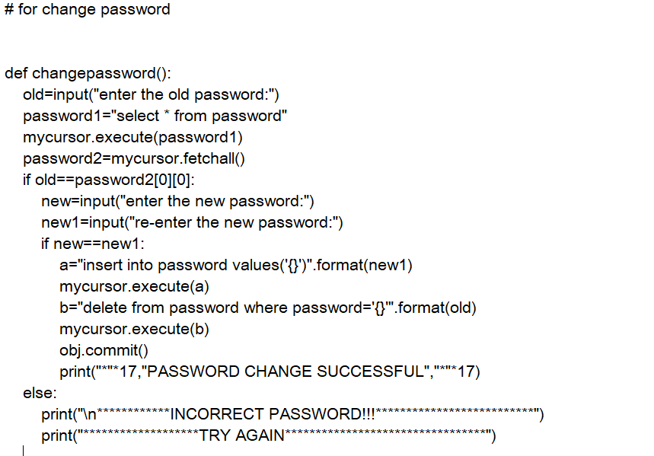

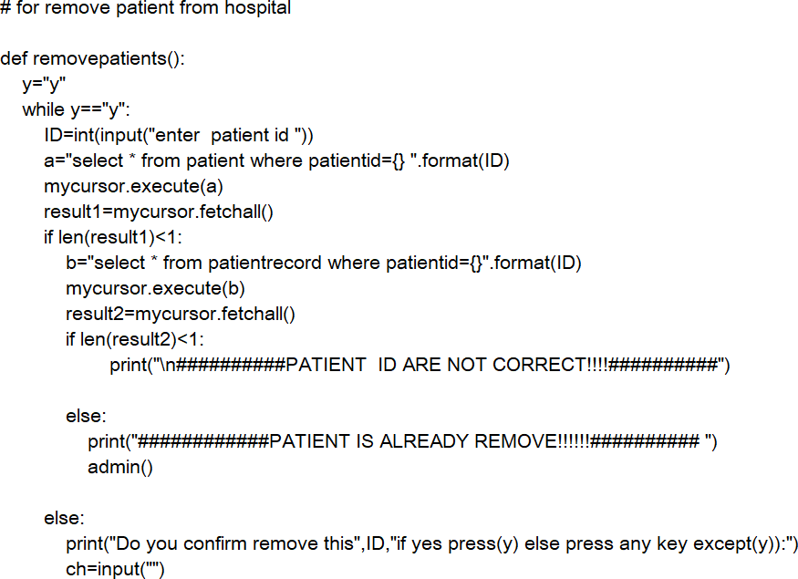

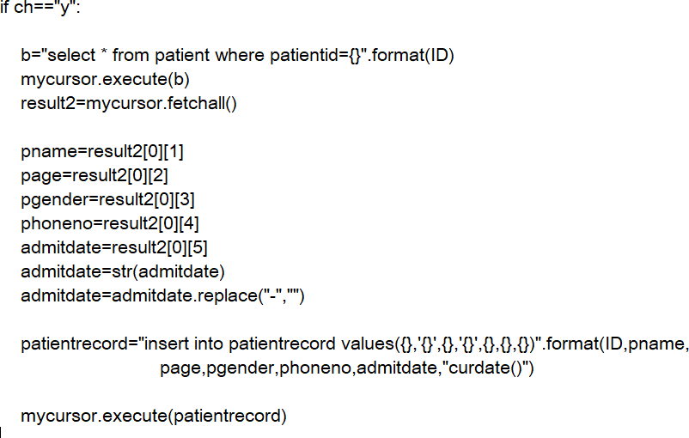

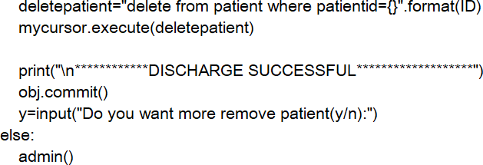

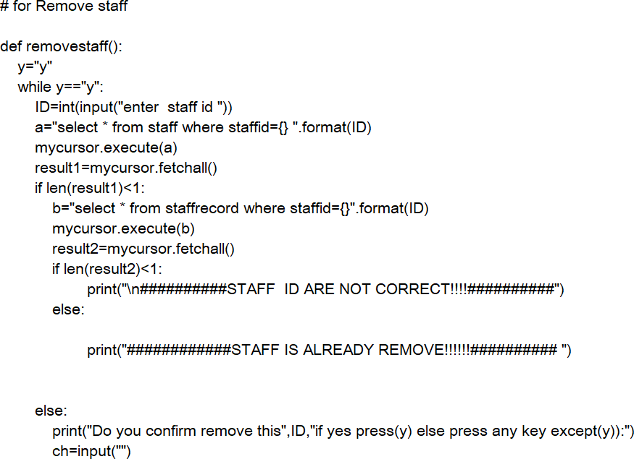

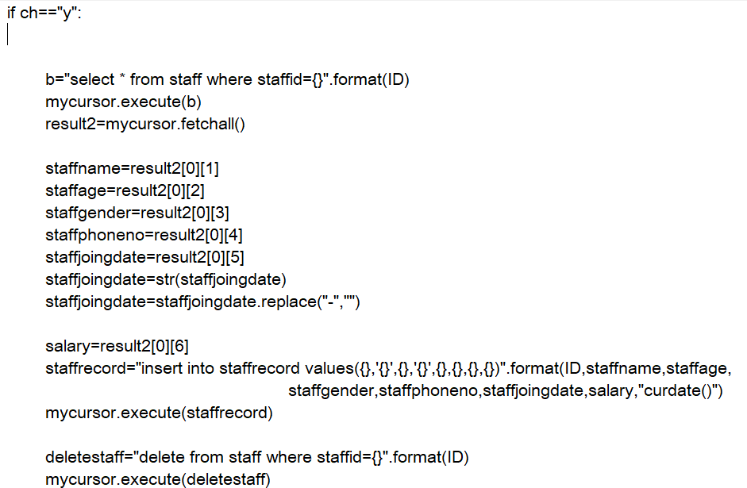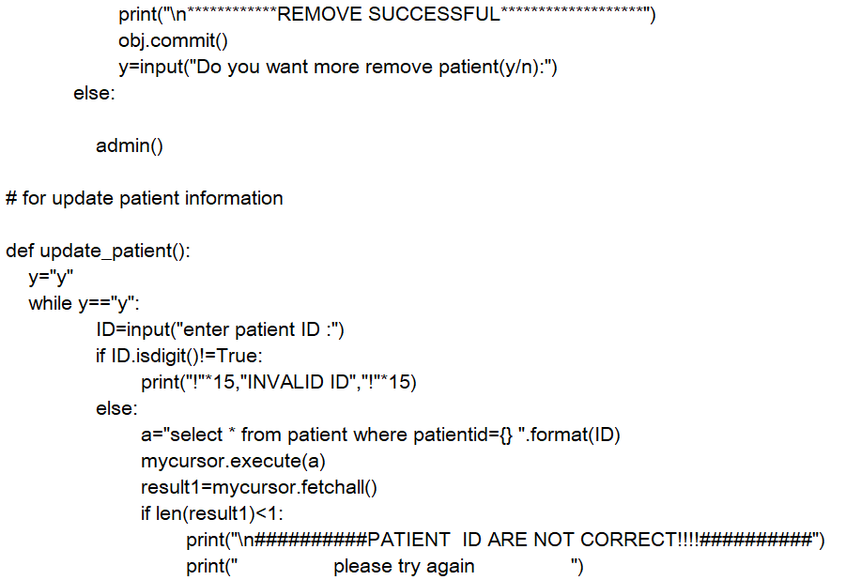

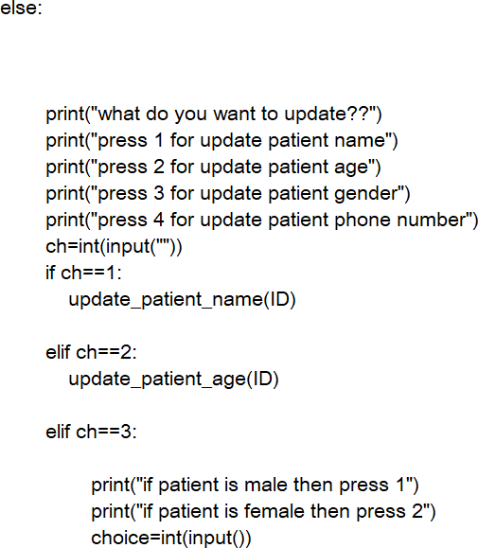

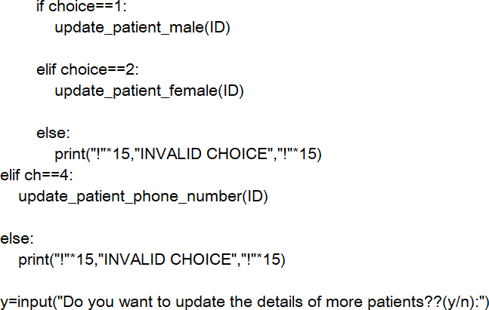

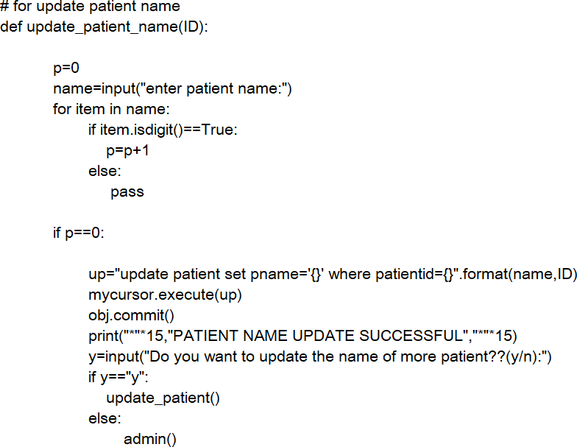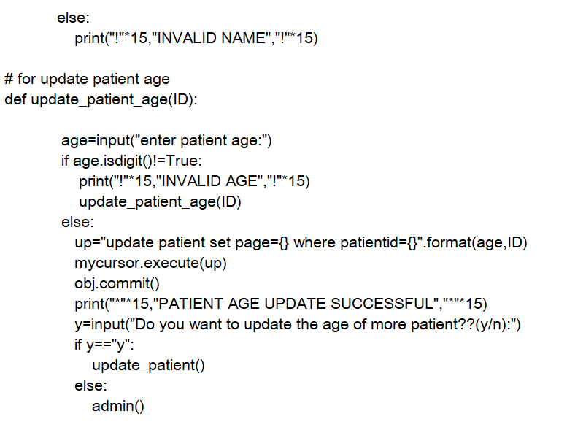

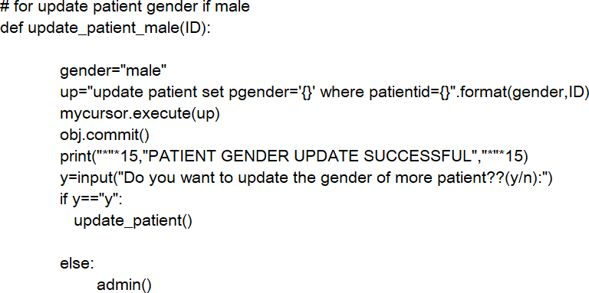

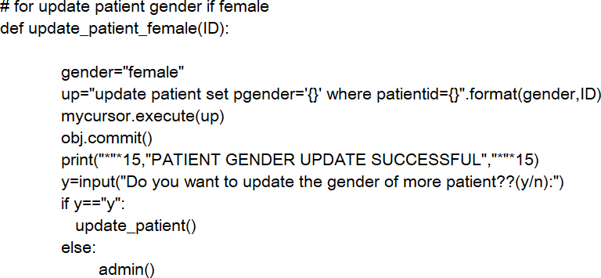

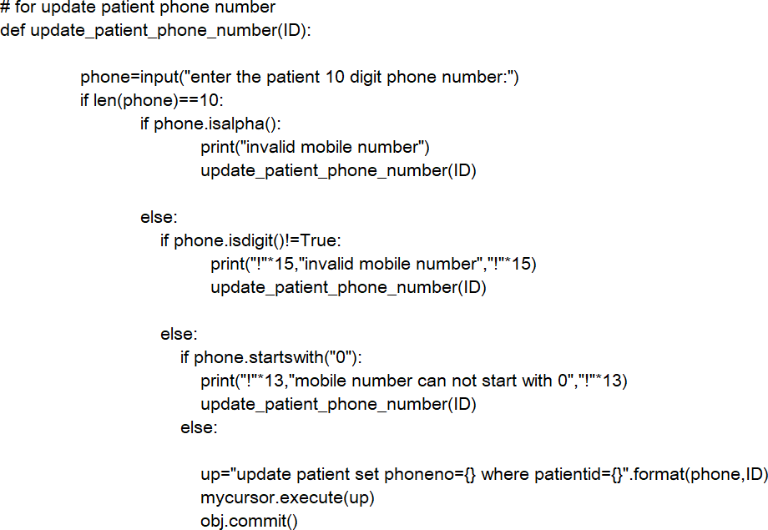

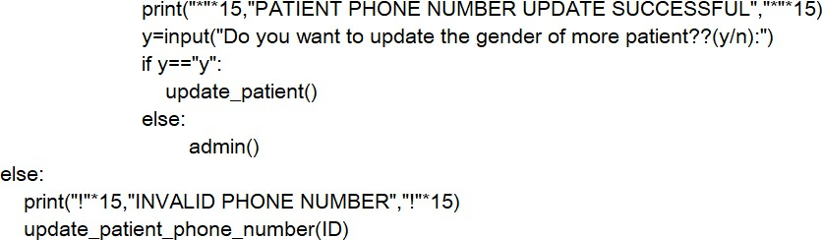

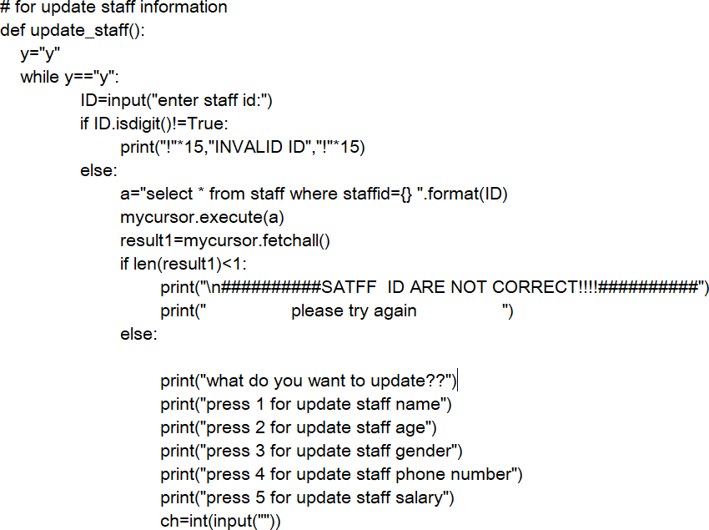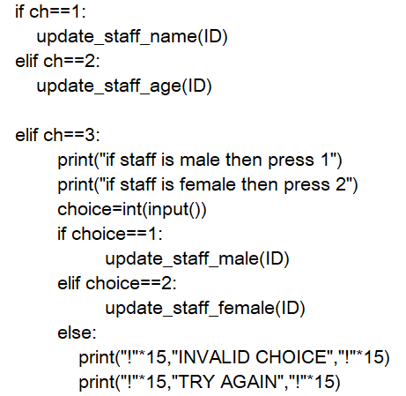

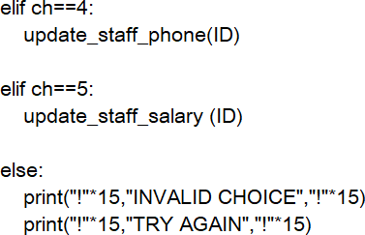

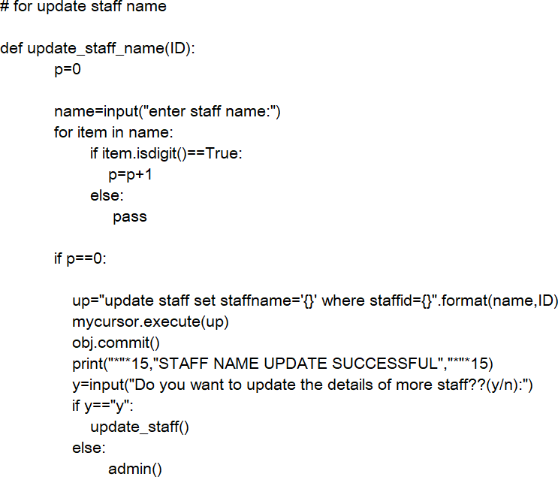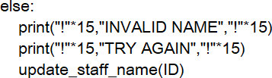

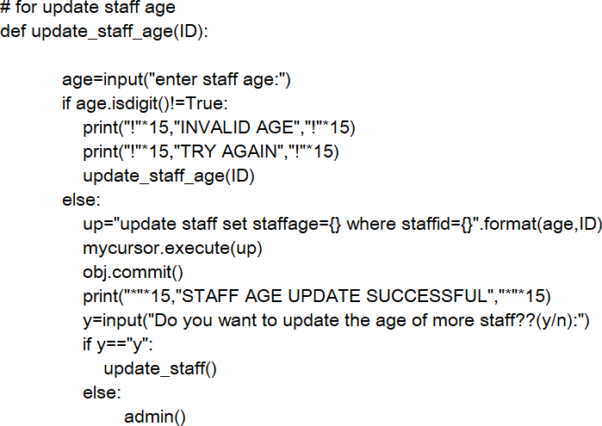

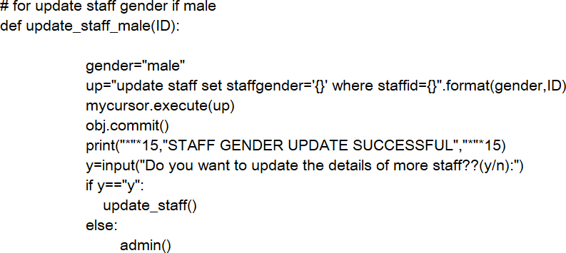

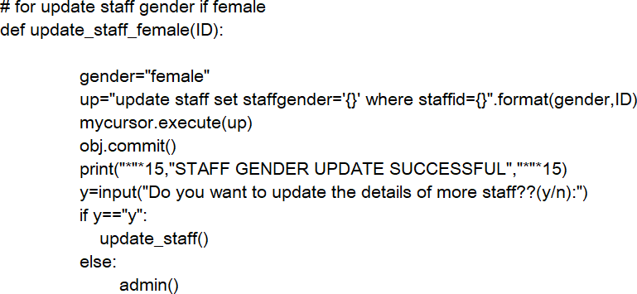

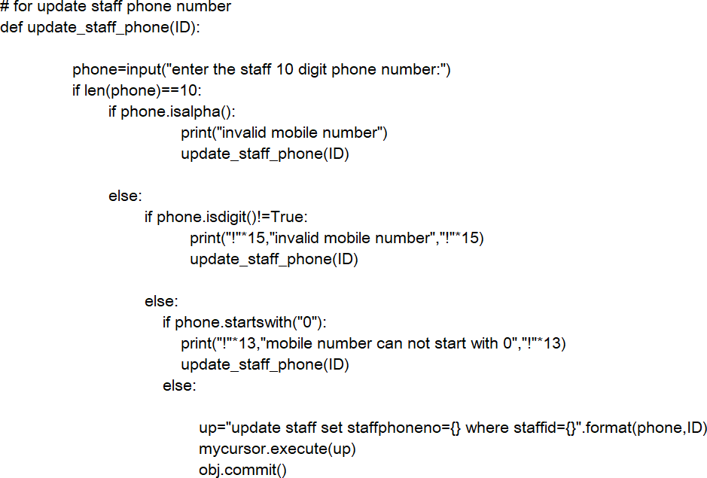

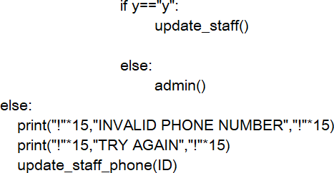

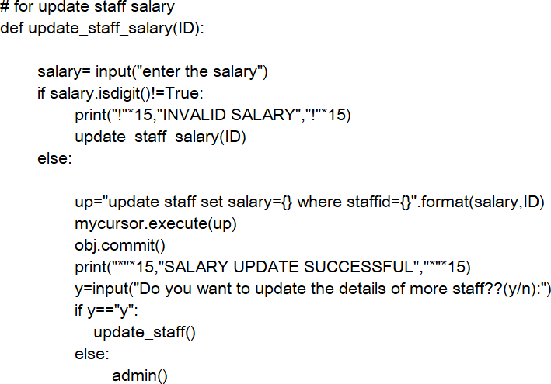

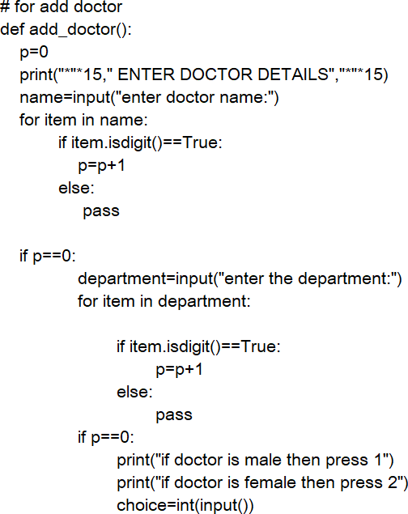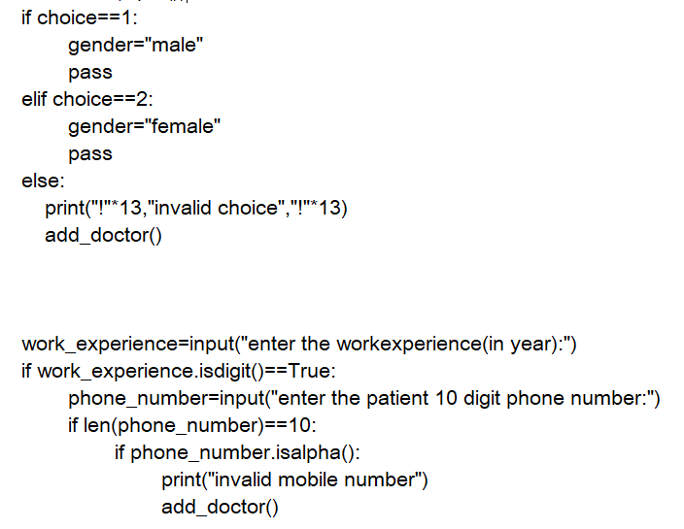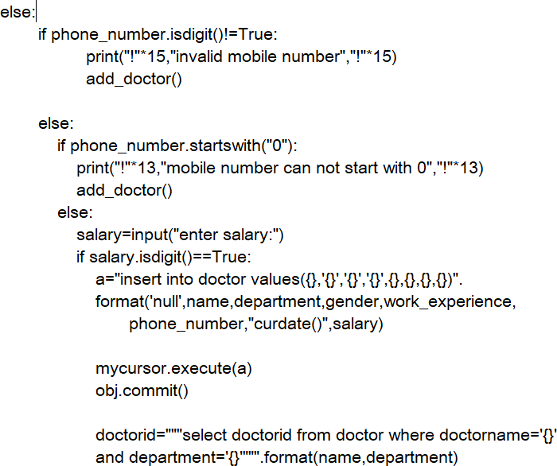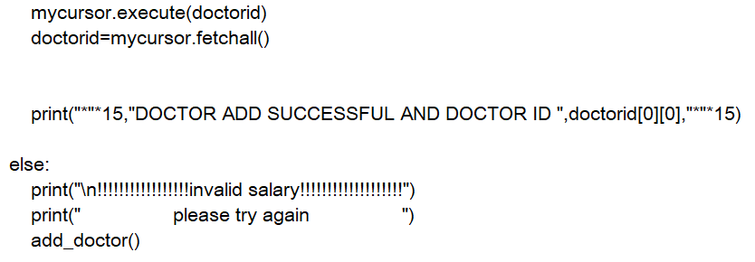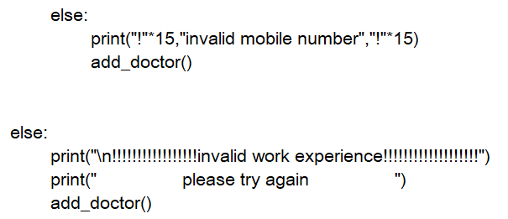

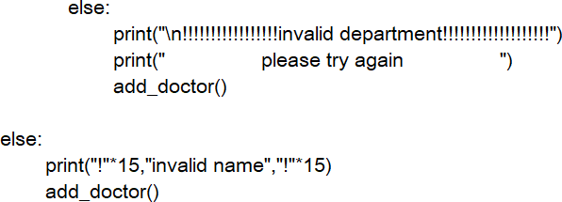

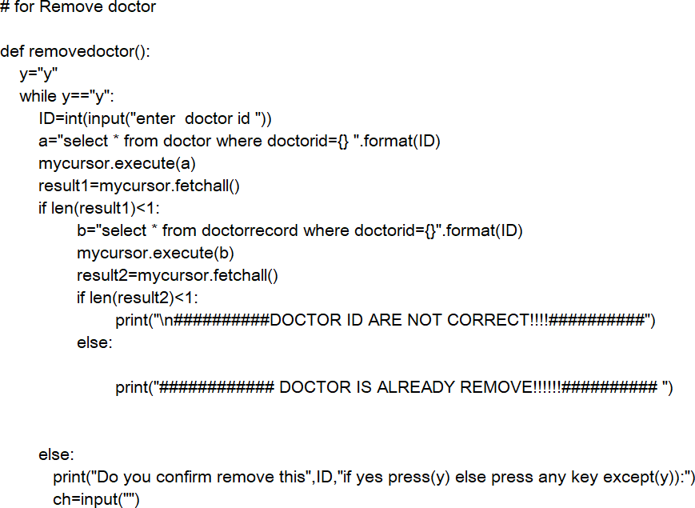

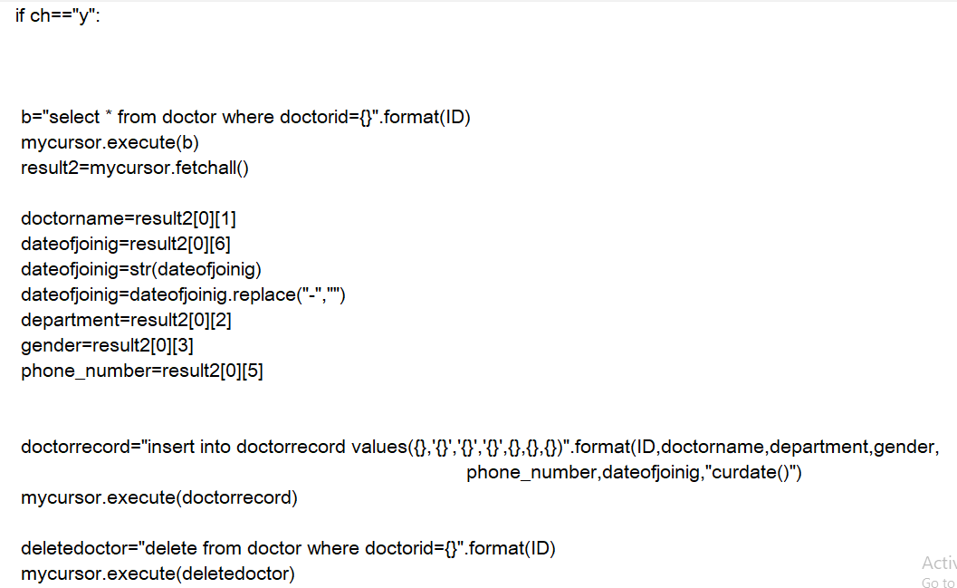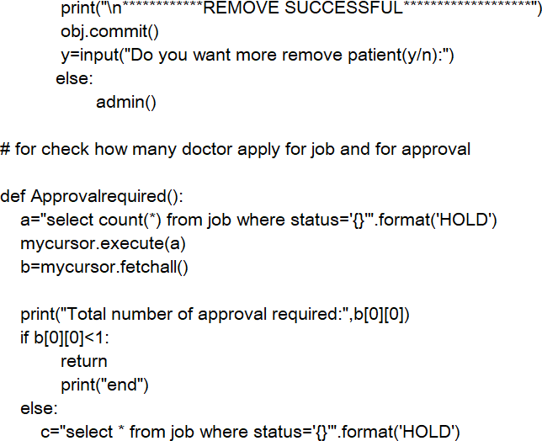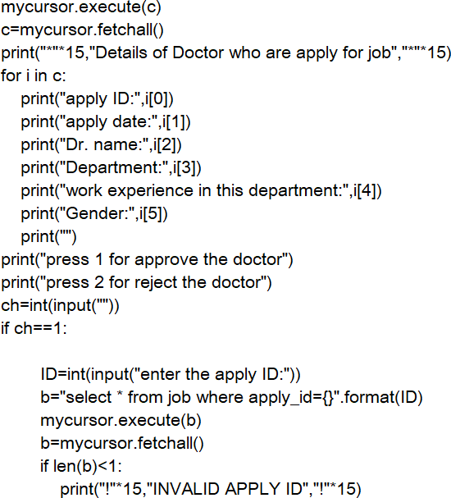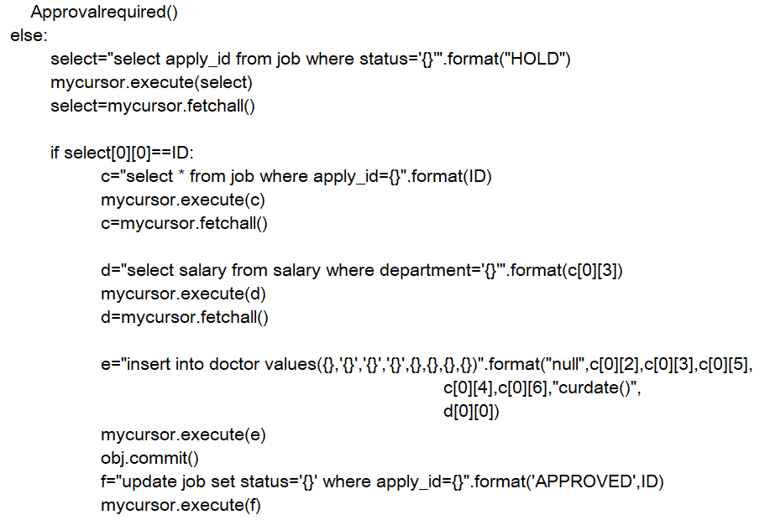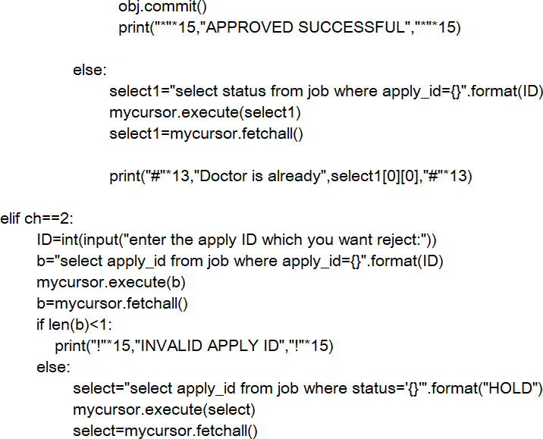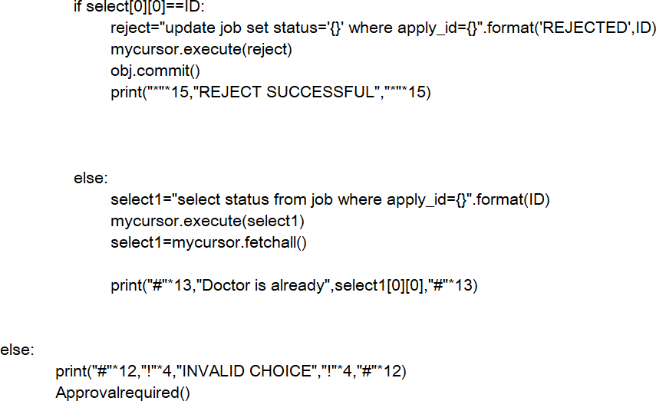

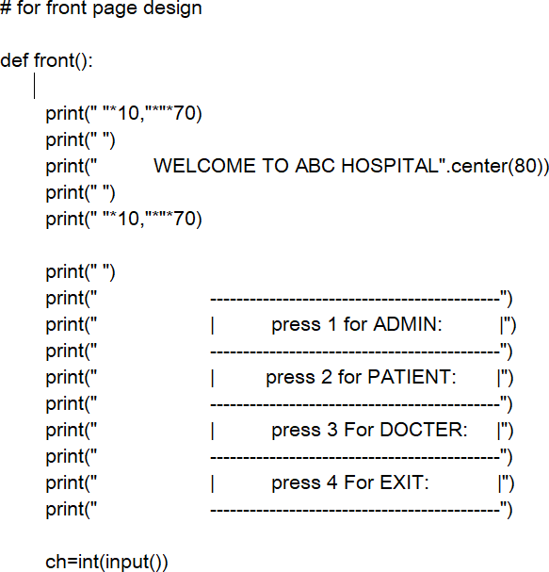

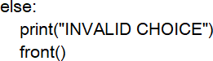

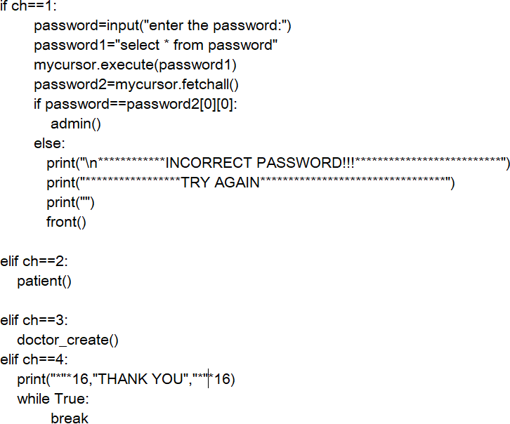

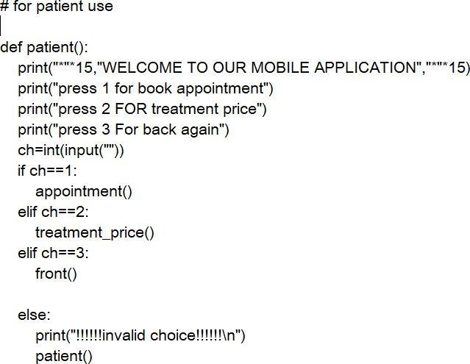

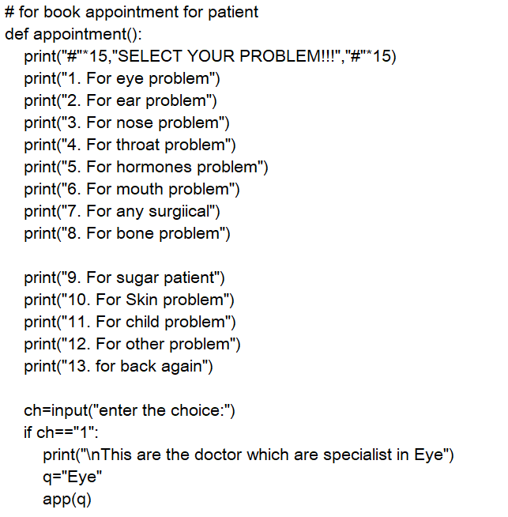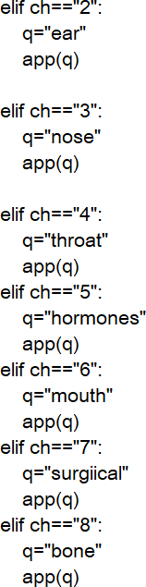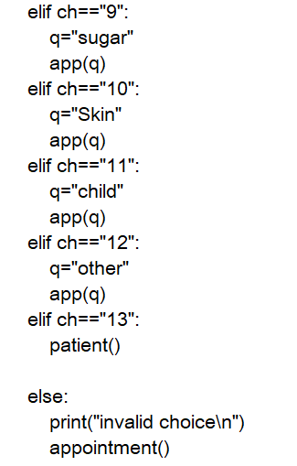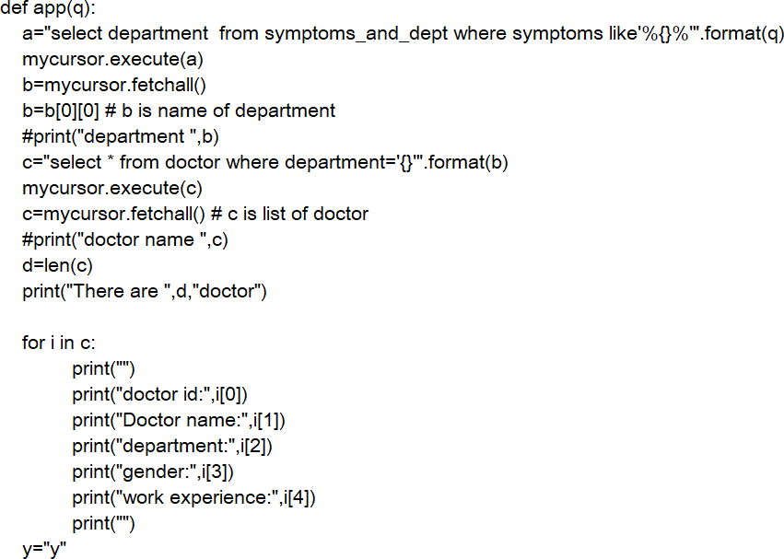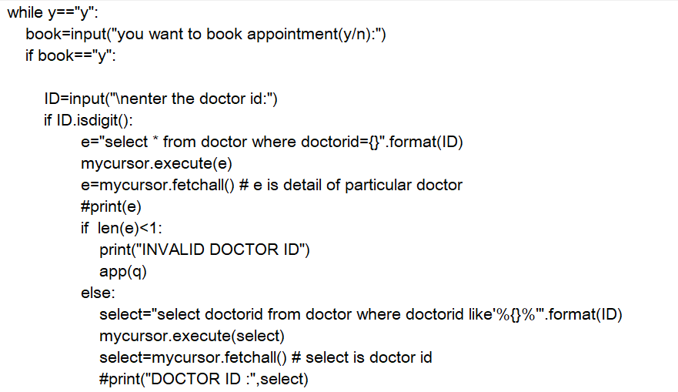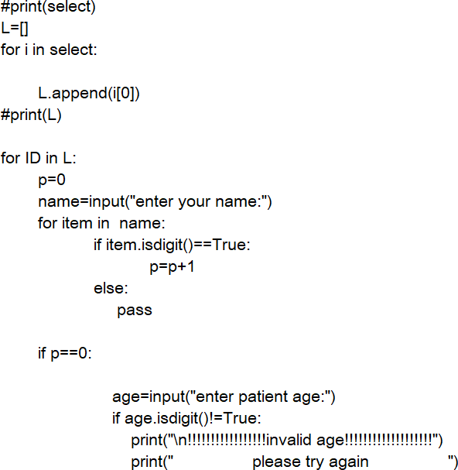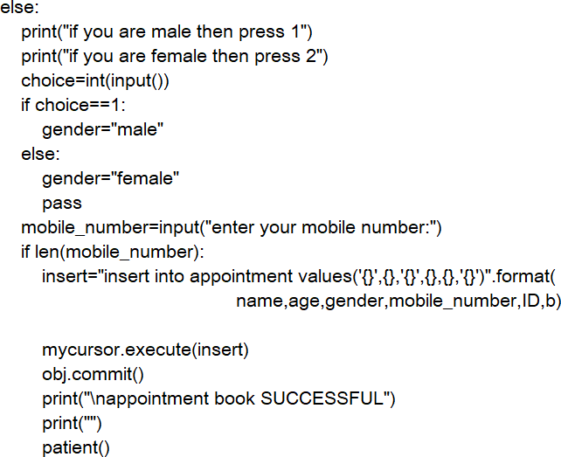

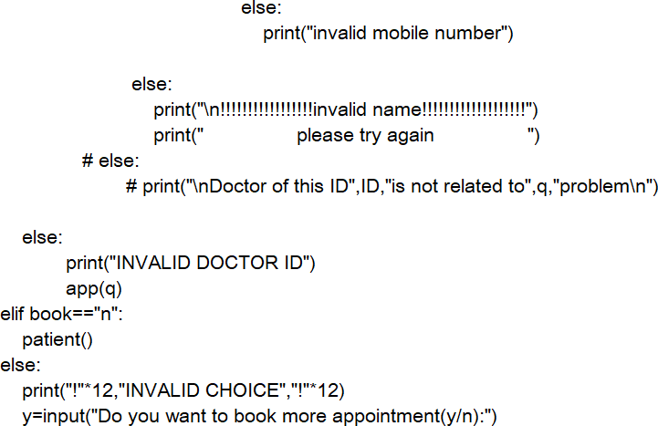

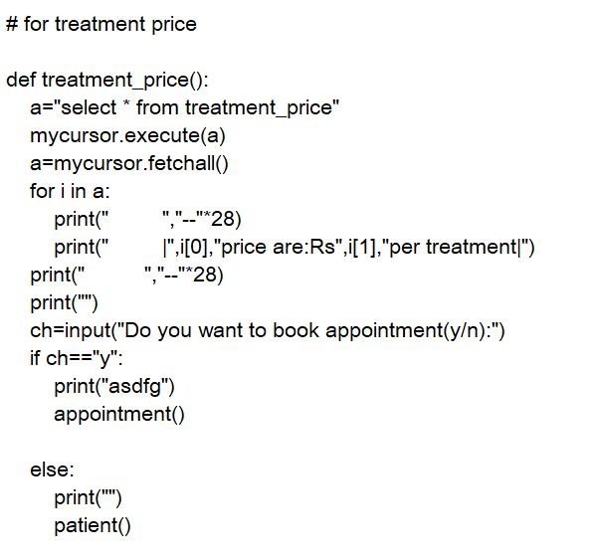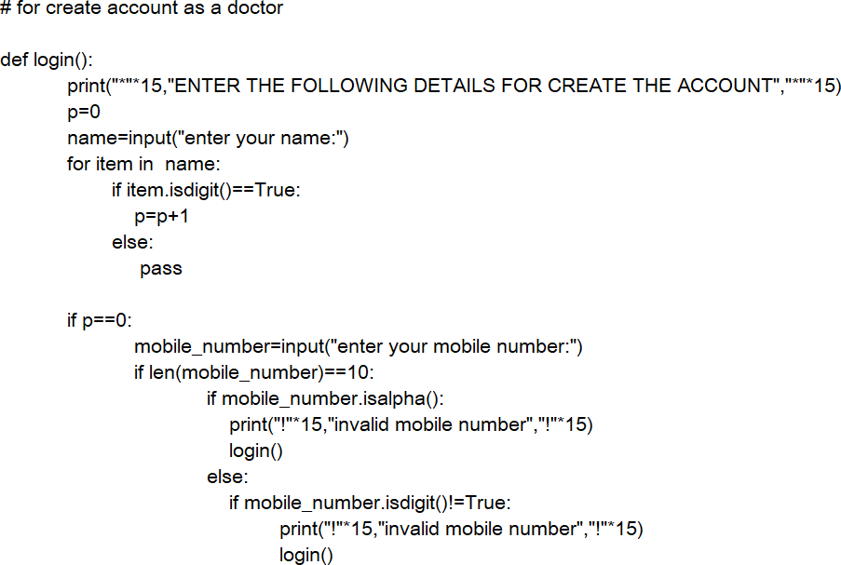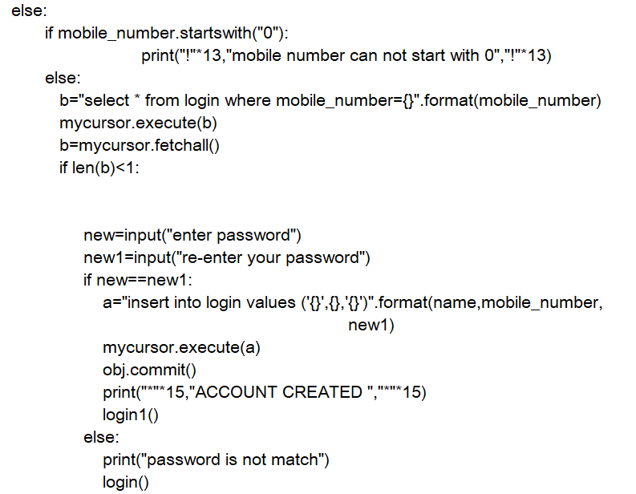

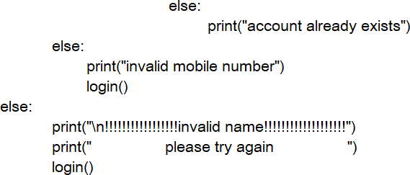

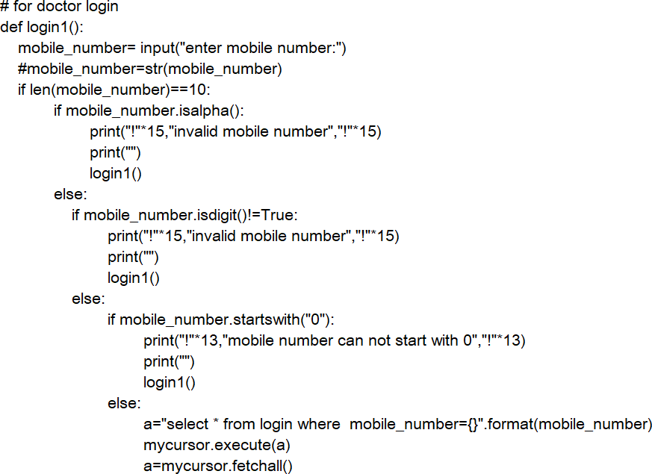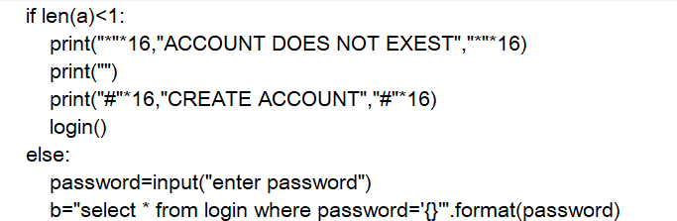

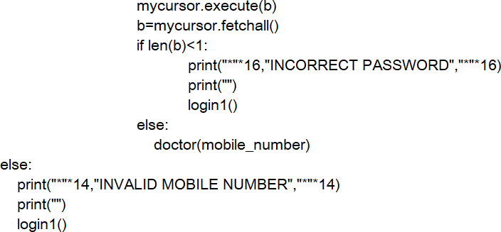

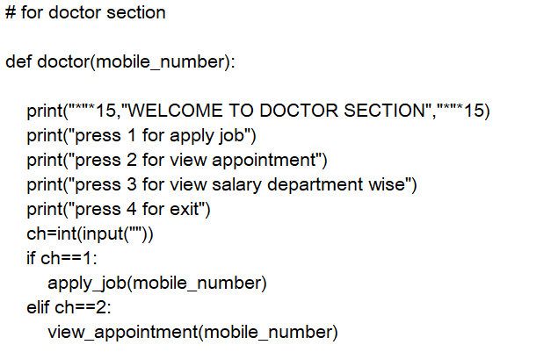

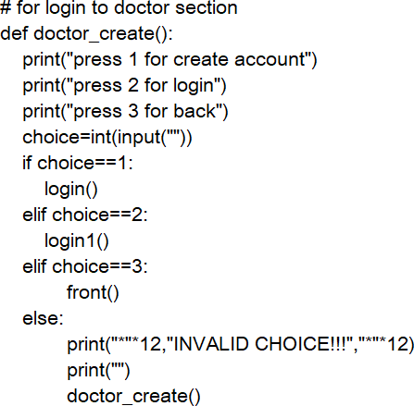

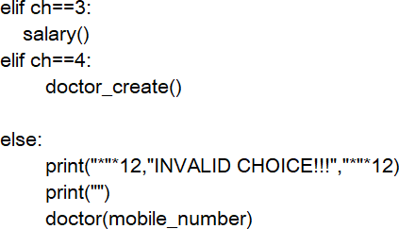

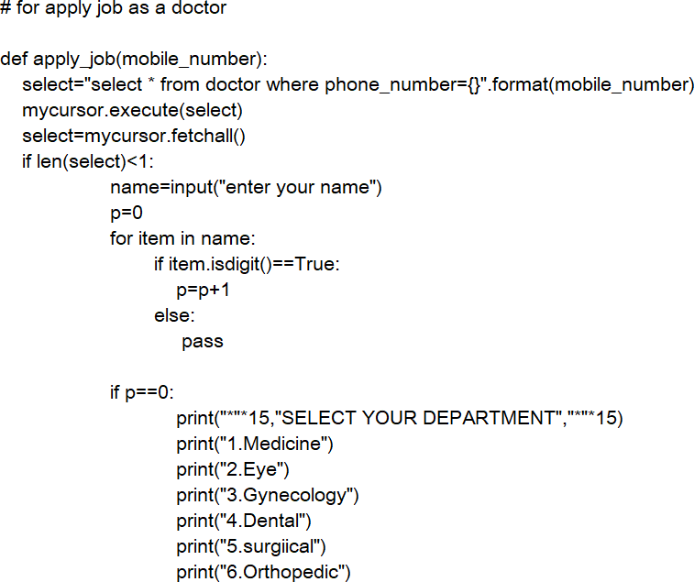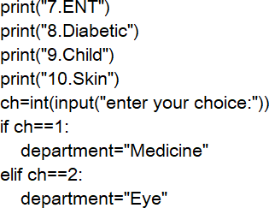

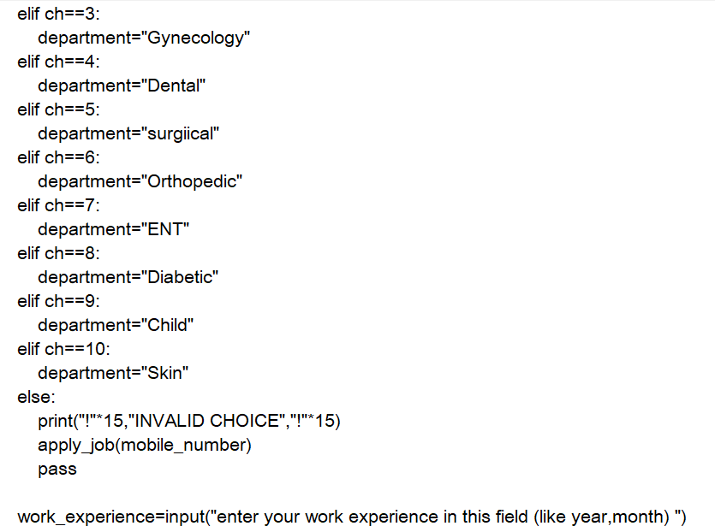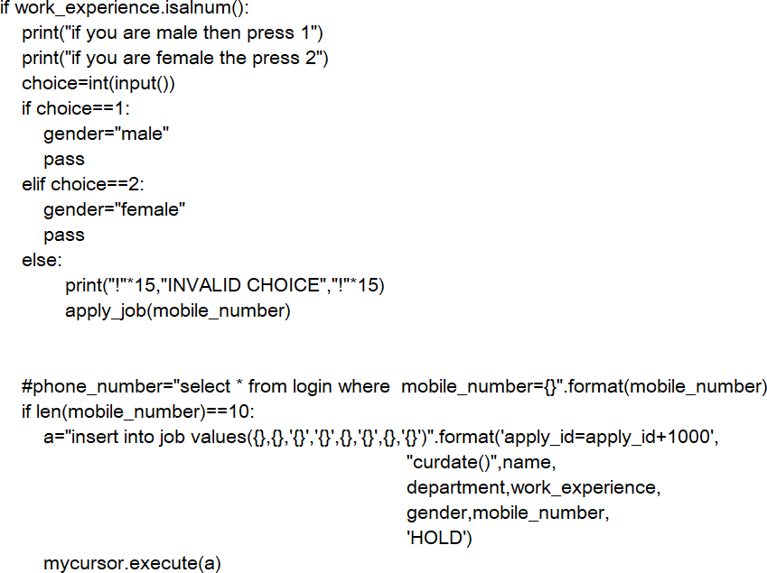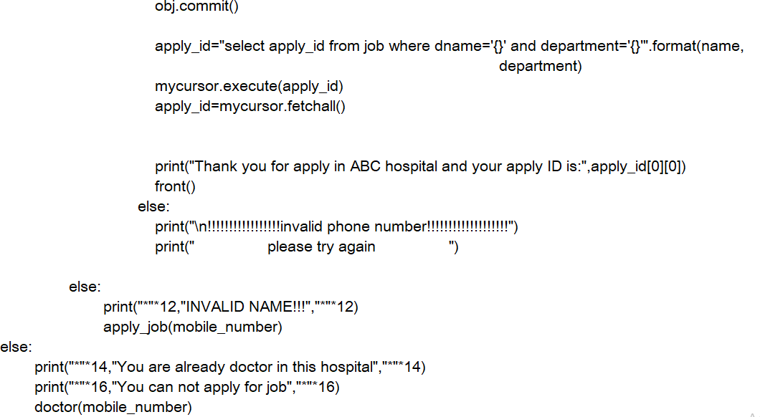

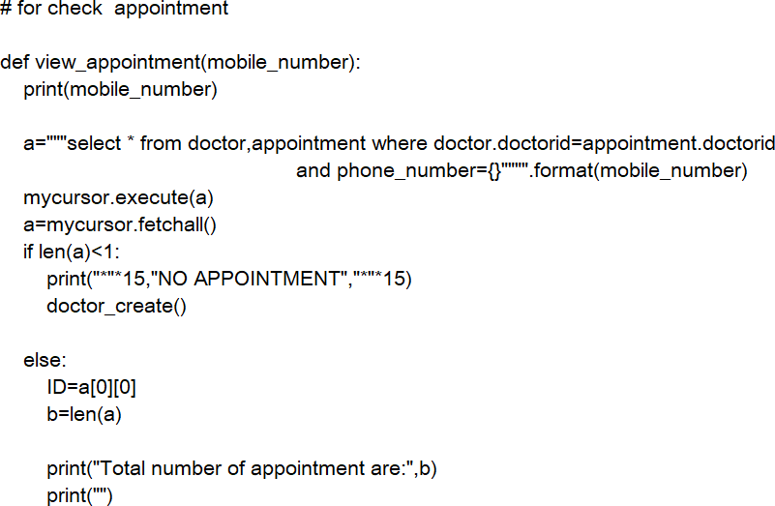

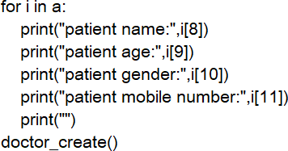

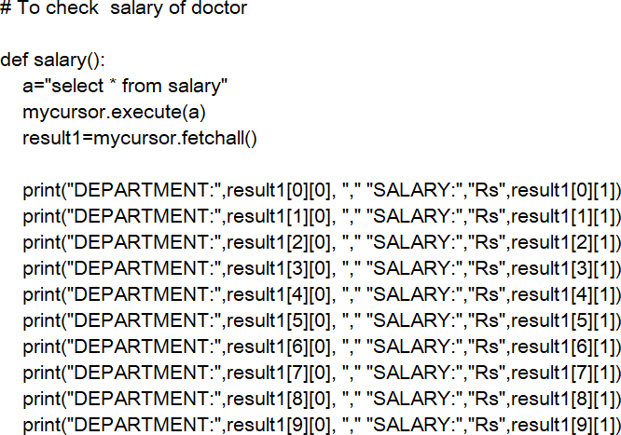

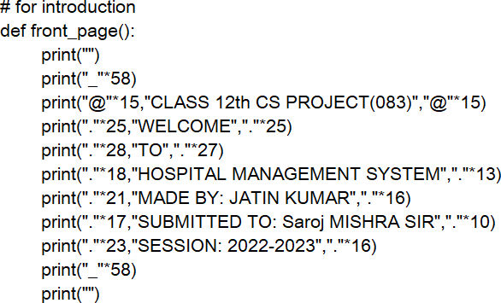

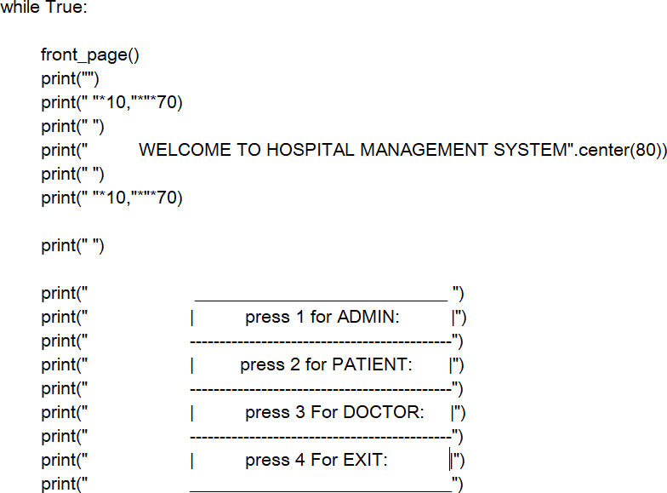

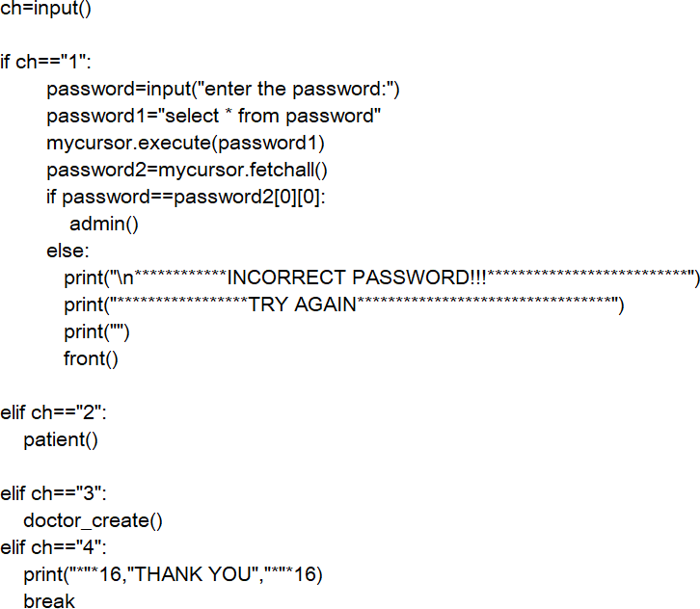



DATABASE

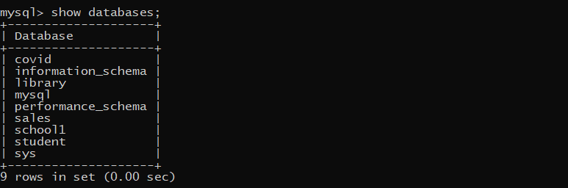

Database name is:- COVID

